4.5.1 Search Activity – Finding classification symbols from an abstract
Using keywords from the abstract in the previous example 4.4.3, determine which of the following search queries might be the best one to enter into the natural language classification tool IPCCAT to find the appropriate IPC symbols.
Alternative (1): An alarm system (100) to wake sleeping occupants in the event of an emergency has a receiver (105) for detecting a warning signal (130) emitted from an external device (125), such as a smoke or carbon monoxide detector.
Alternative (2): alarm system warning signal smoke or carbon monoxide detector predetermined signal transmitter audible communication voice
Alternative (3): alarm system
Alternative (4): Use the entire abstract text quoted above
Check the IPC symbols suggested by the system against the current edition of the IPC.

Answer Search Activity 4.5.1

On IPC Publication Platform select Advanced Search then select the IPCCAT tool.

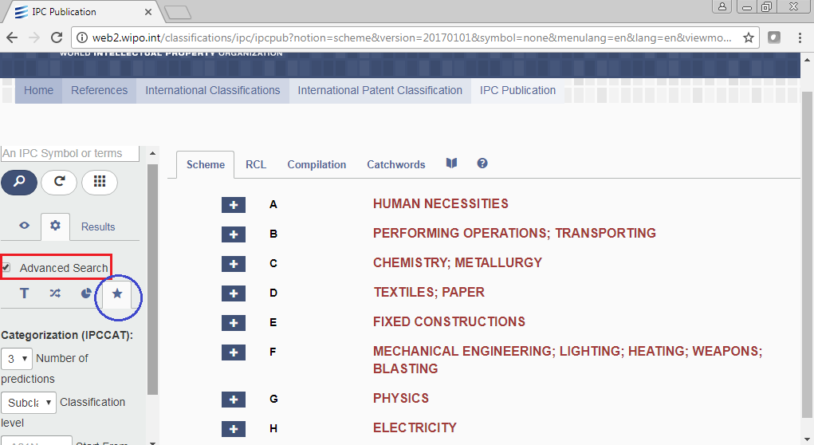

Select the preferred number of predictions and classification level.

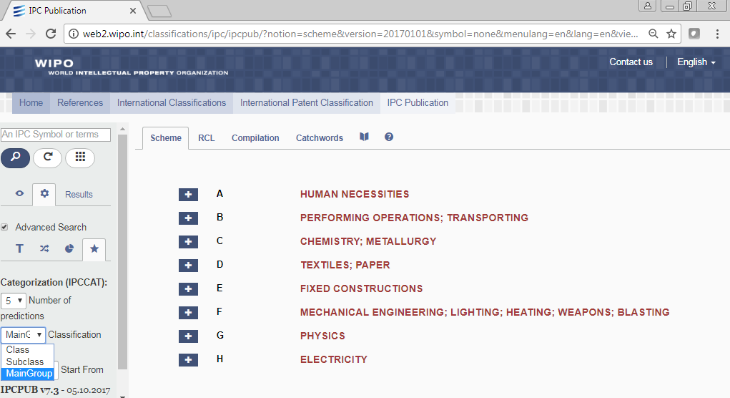
Input the text of each alternative and search.
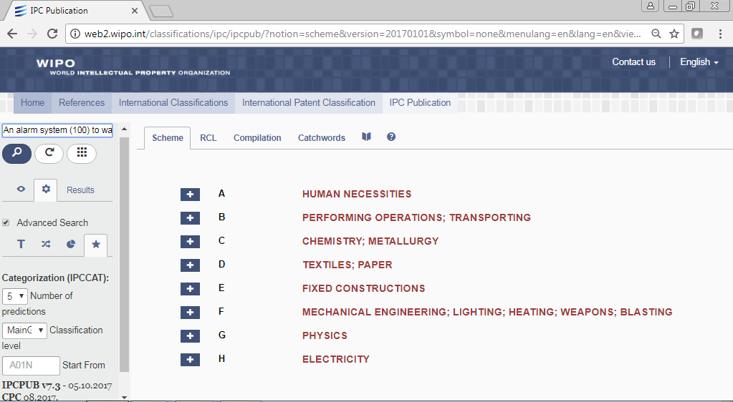

Check the results under IPCCAT

Alternative (1)
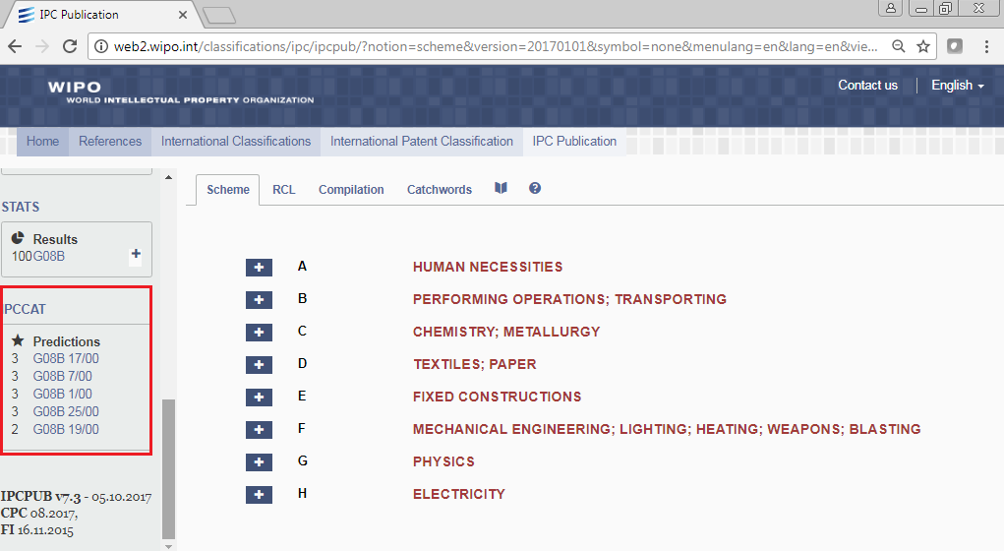

Alternative (2)
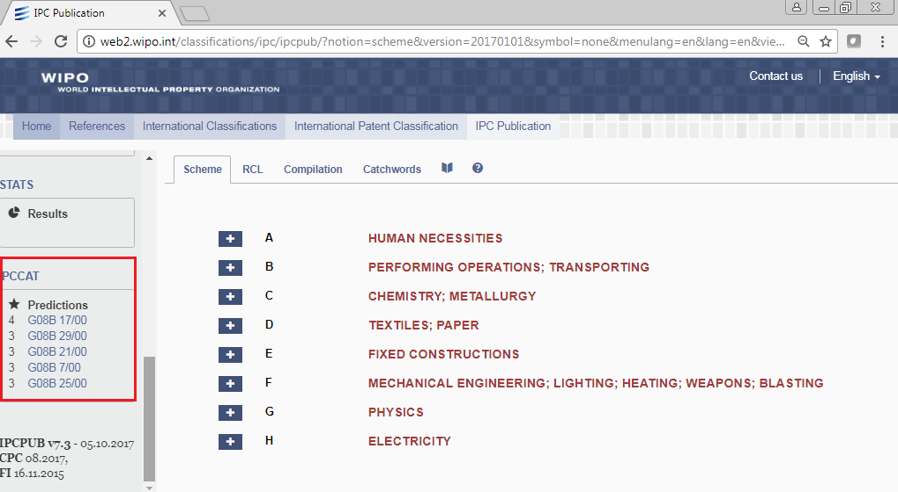

Alternative (3)
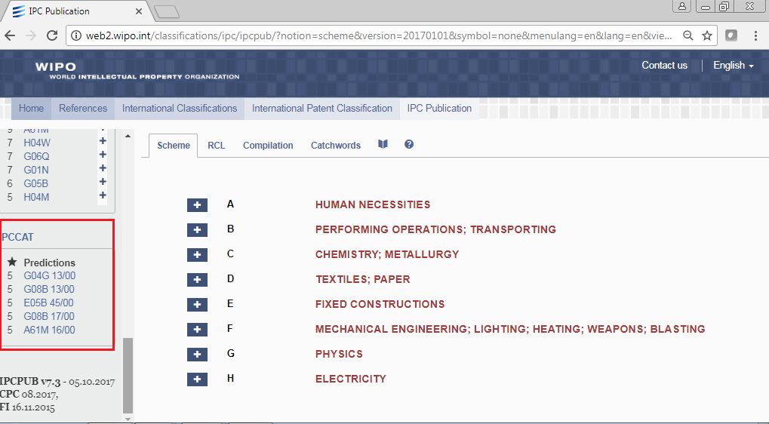
Alternative (4)
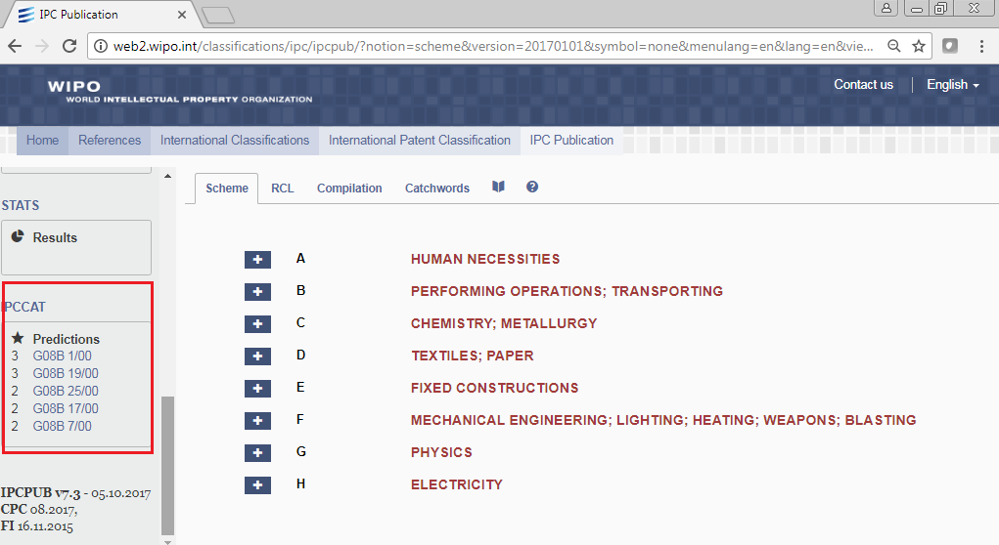
Click on the IPC symbols to get the corresponding Titles and then identify which of these IPC symbols are more relevant to the described invention.
IPC symbols G0B17/00, G0B25/00 and G0B19/00 seem to be very relevant.
Alternatives (1), (2) & (4) all provide relevant IPC symbols. This is because all include multiple features of the invention. However, sometimes using the whole text of the abstract might not be advantageous because of the probability of getting non relevant results connected with keywords or terms that are not very specific for the invention.
Alternative (3) was not very specific with regard to the described invention and this was reflected on results.
* Read more about the use of IPCCAT and other automatic search tools on the IPC guide and help links on WIPO IPC Publication Platform.

Please note that the IPC tools are not intended to replace manual classification by someone who is experienced in IPC classification

